C950 Task-2 WGUPS Write-Up

Bryan Huynh
ID #011920597
WGU Email: hhuyn35@wgu.edu
03/09/2026

C950 Data Structures and Algorithms II

A. Hash Table
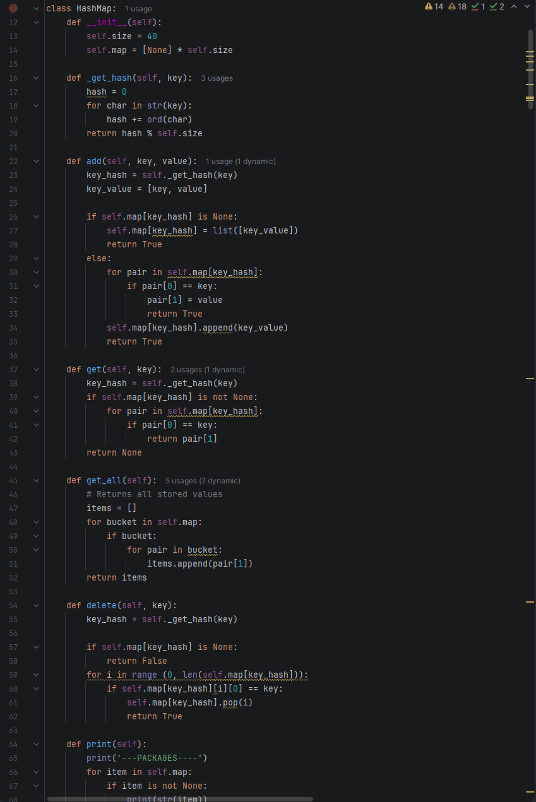
(Programming and Math Tutorials, 2016).

B. Look-Up Functions
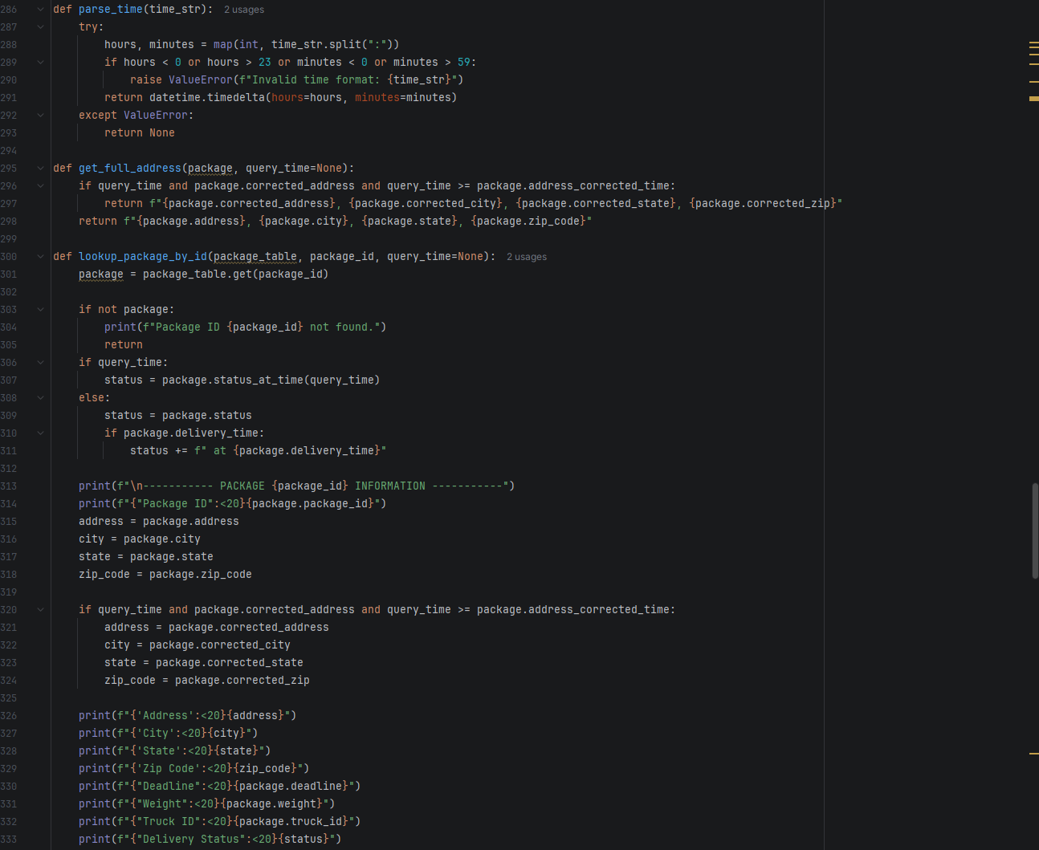

C. Original Code
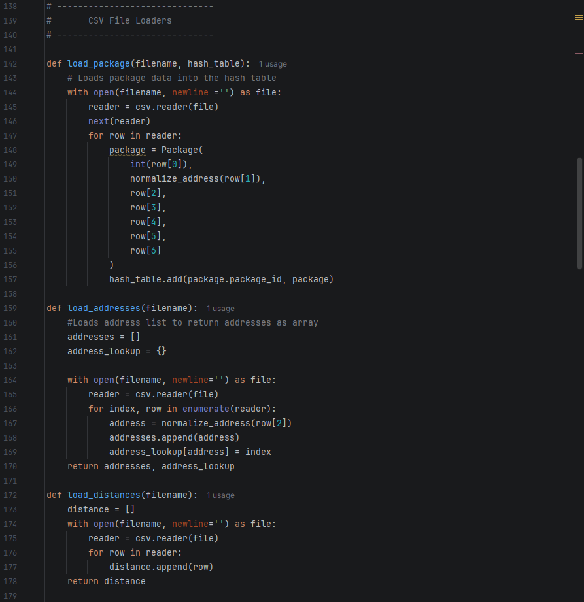

C1. Identification Information
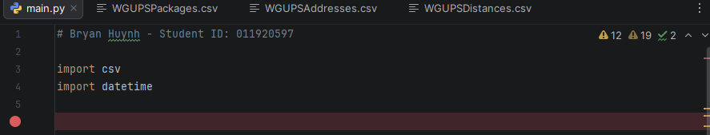

C2. Process and Flow Comments
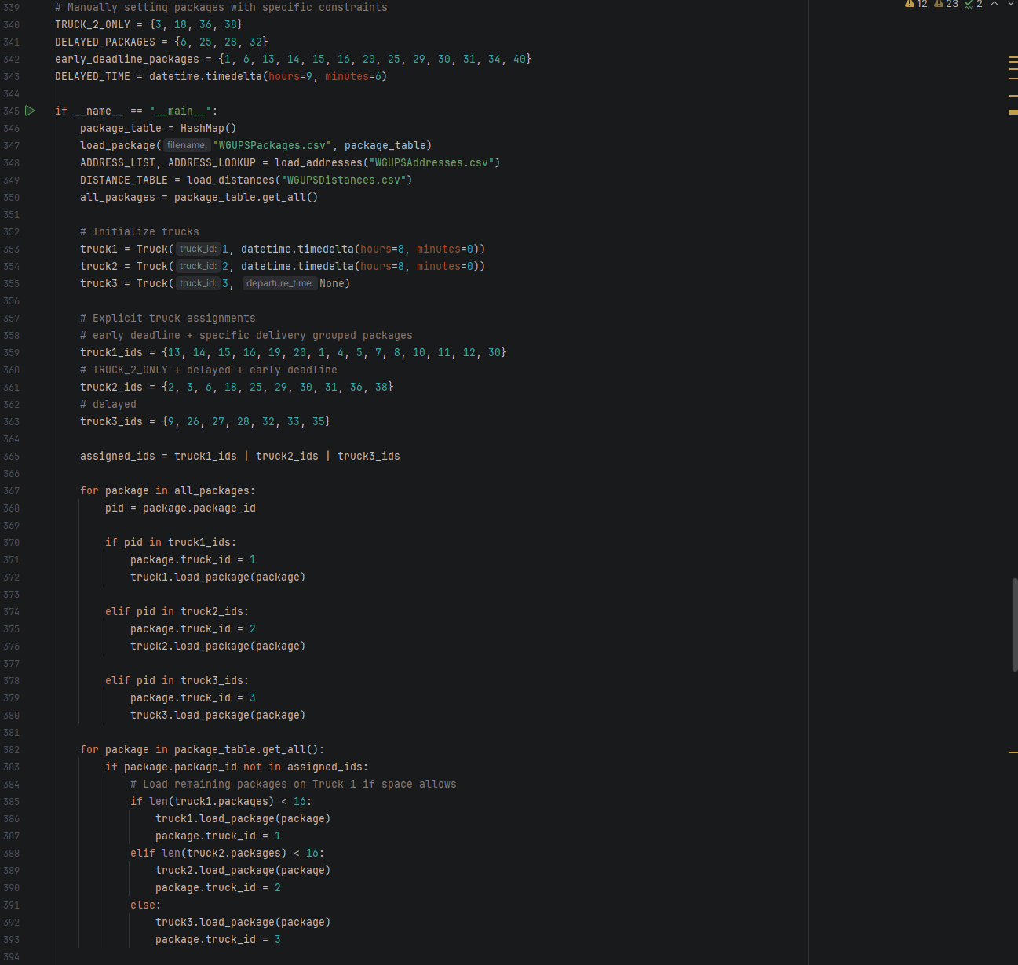
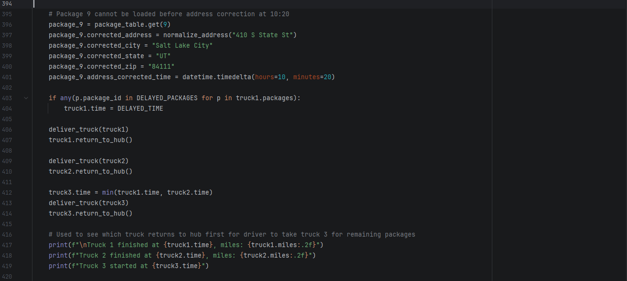

D. Interface
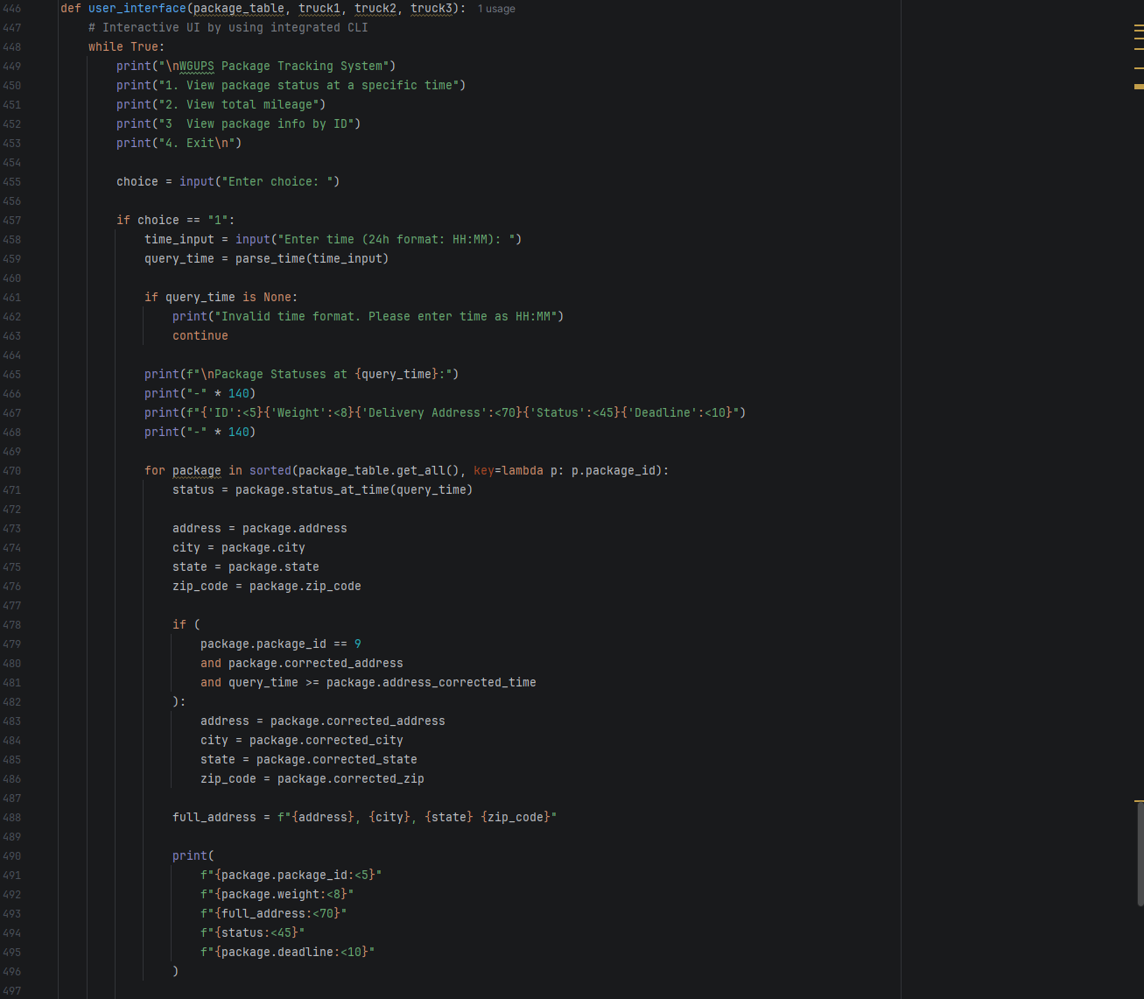
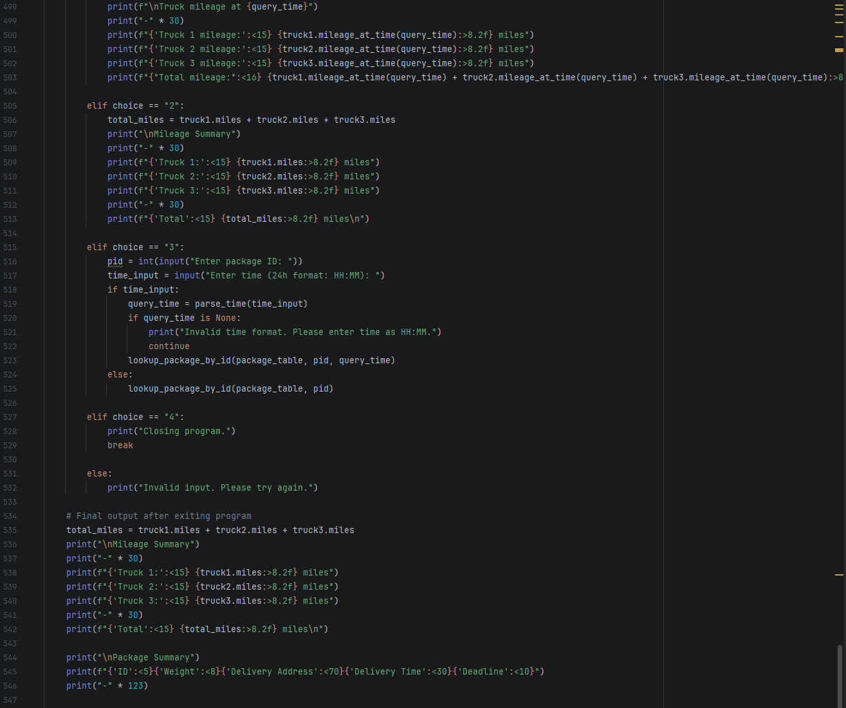
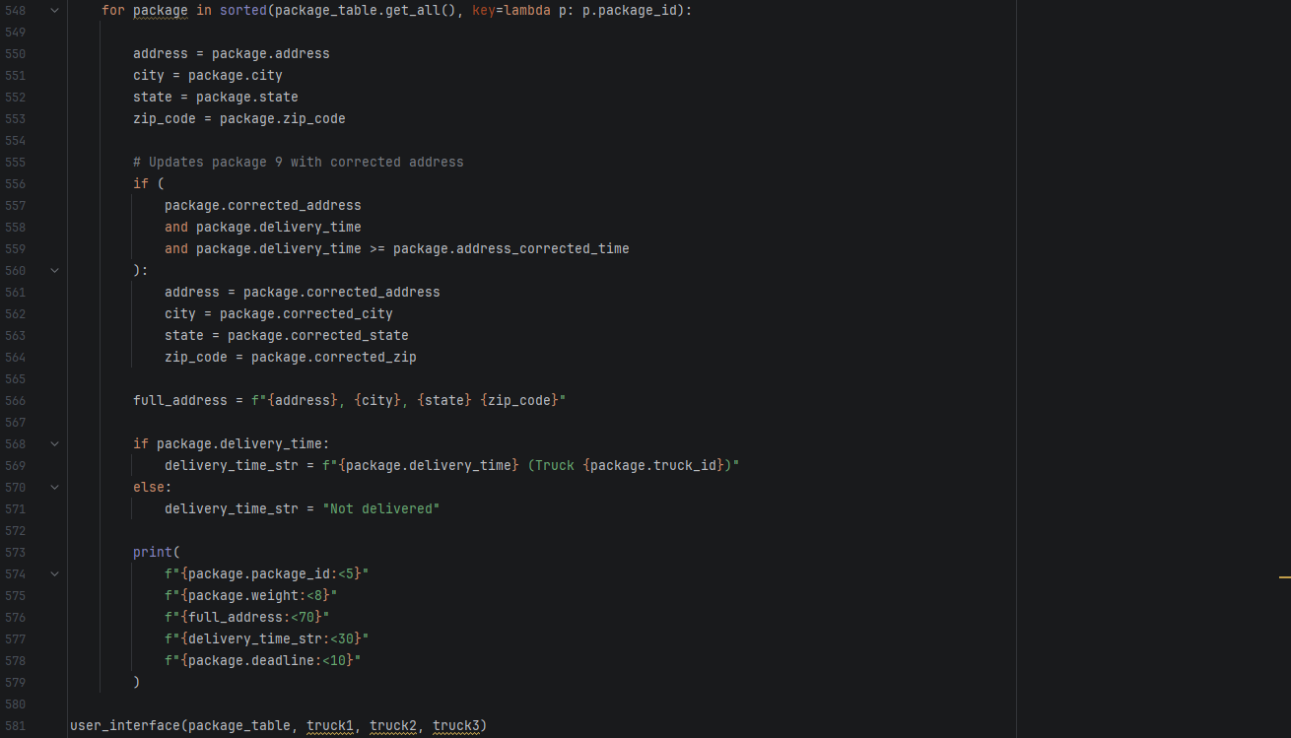
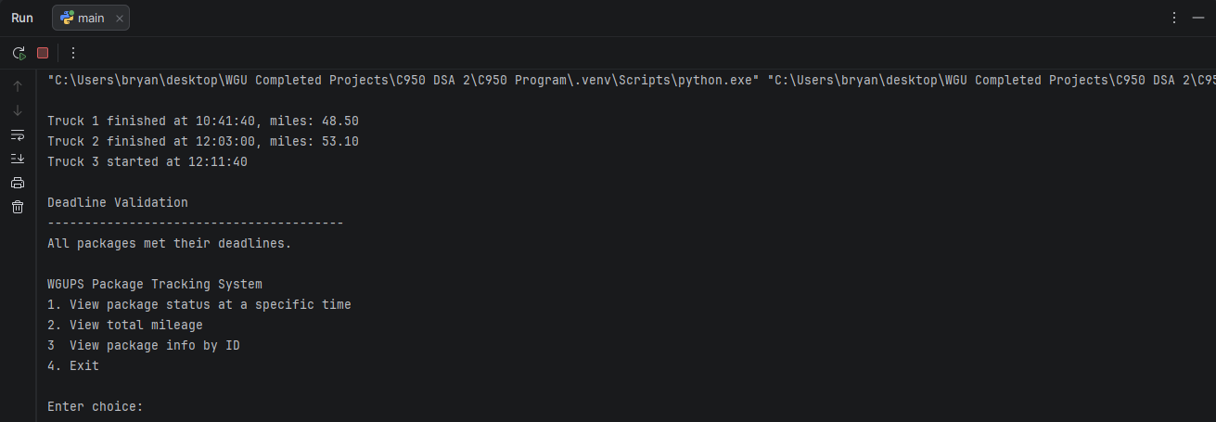

D1. First Status Check
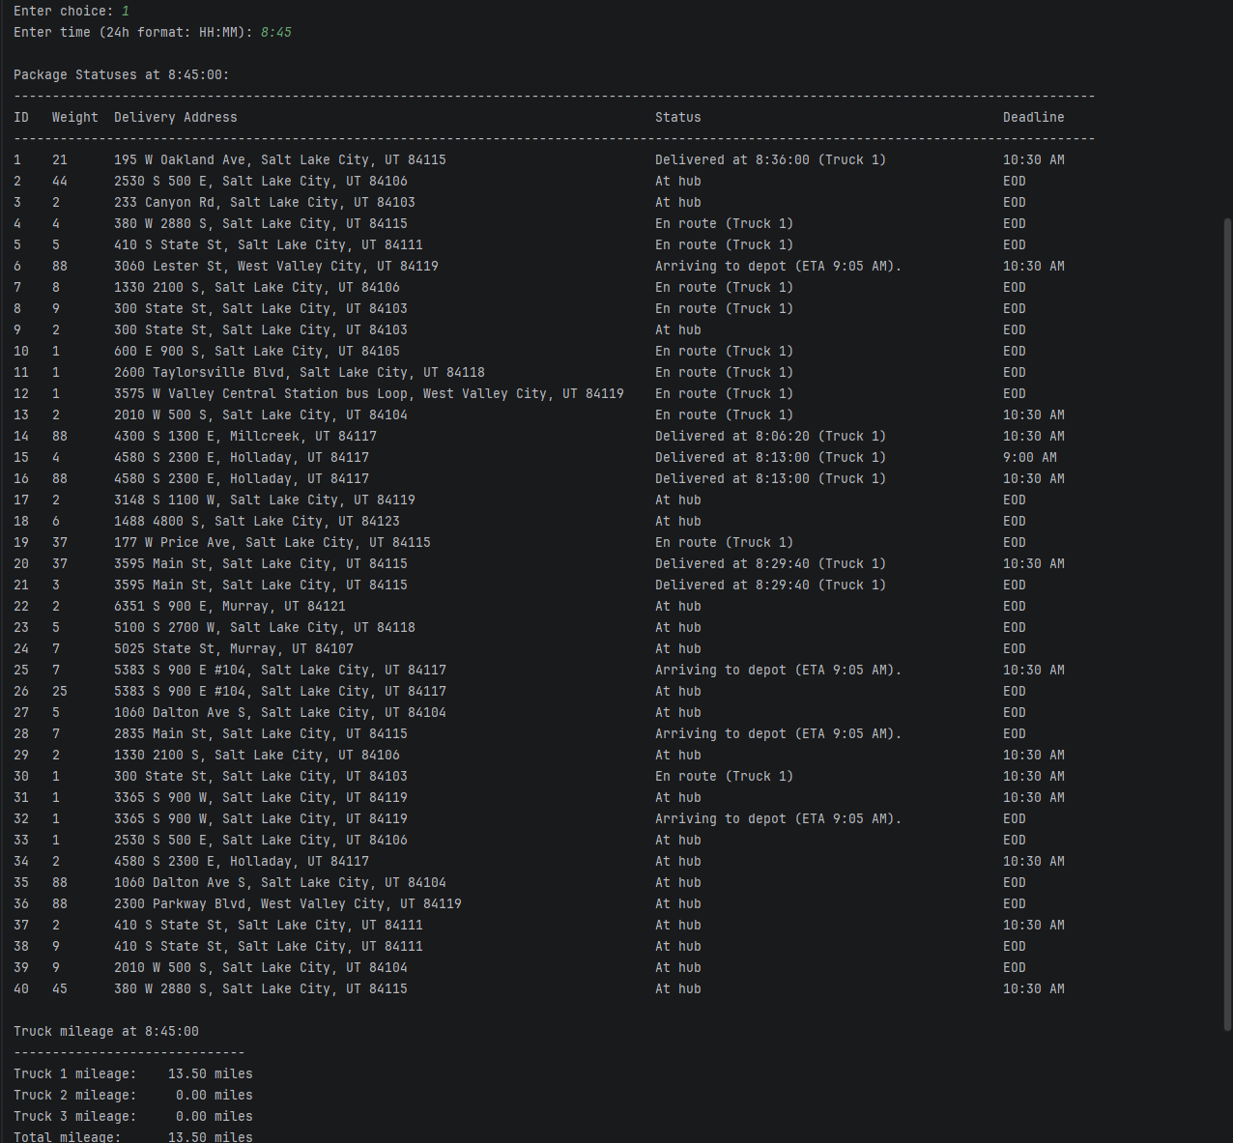

D2. Second Status Check
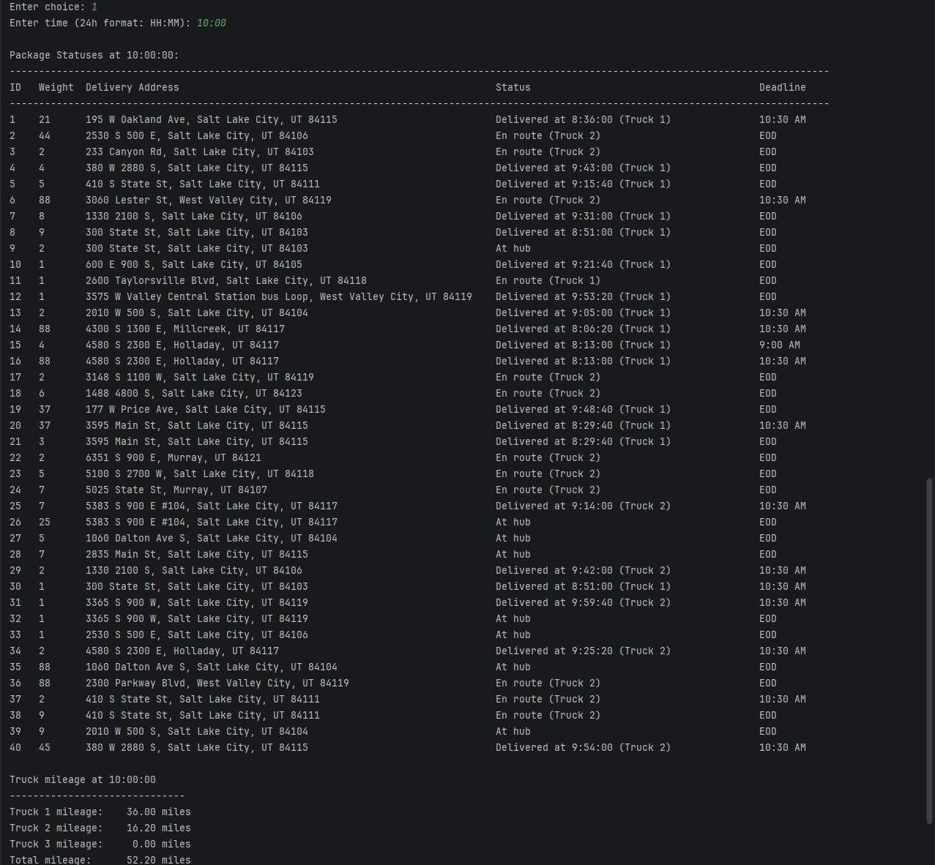

D3. Third Status Check
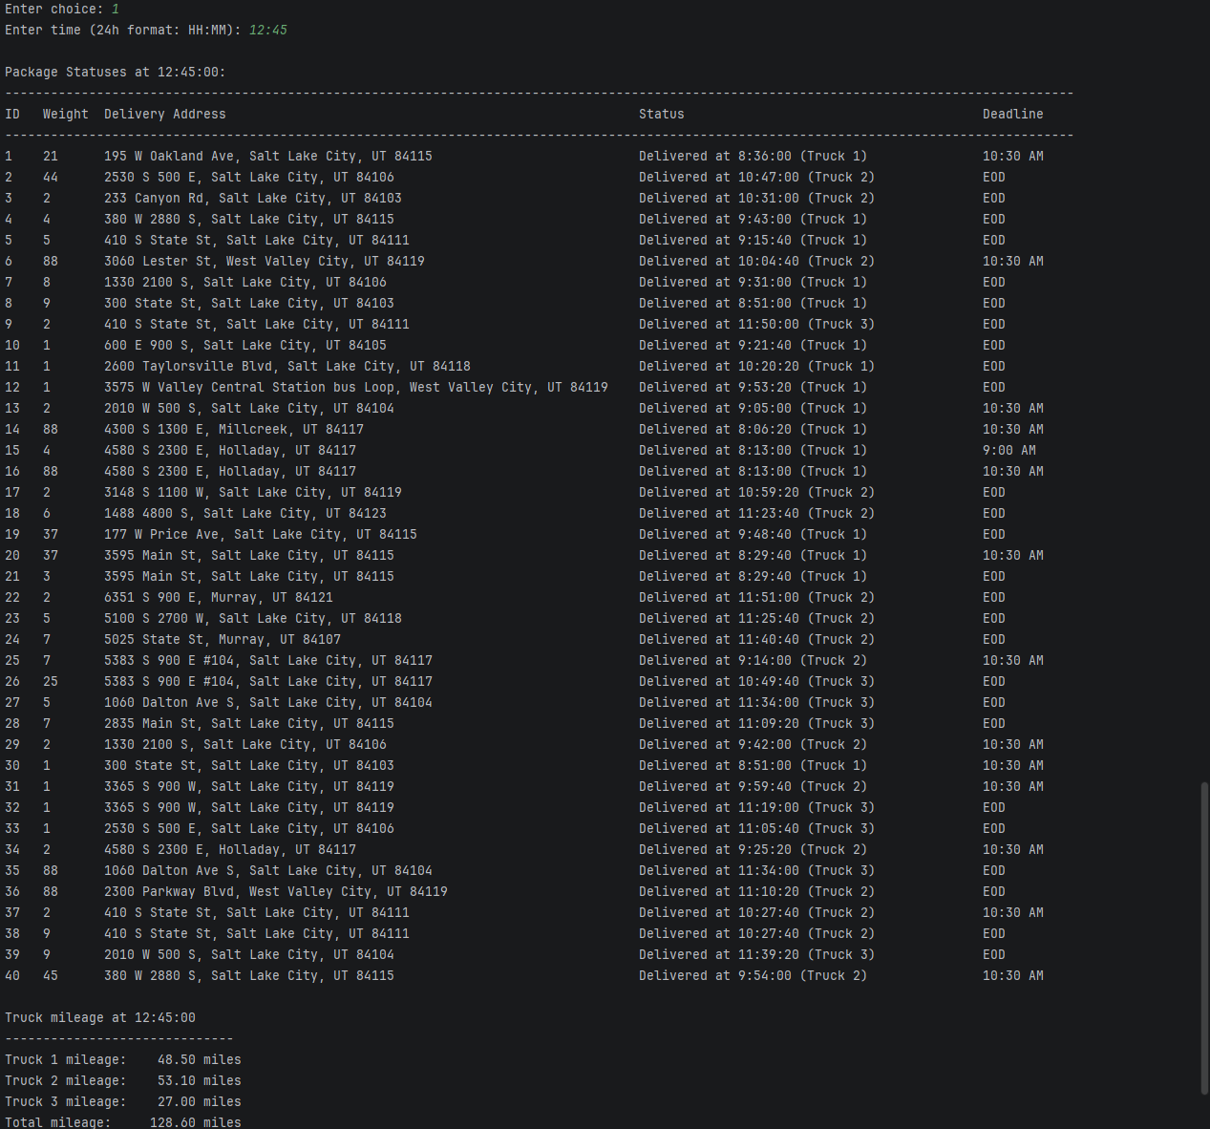

E. Screenshot of Code Execution
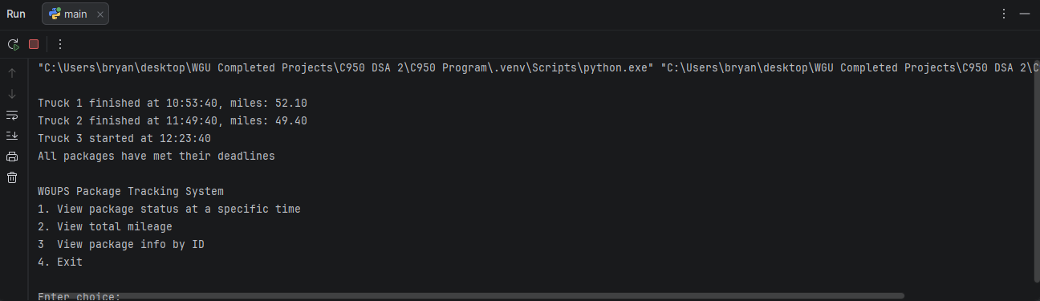
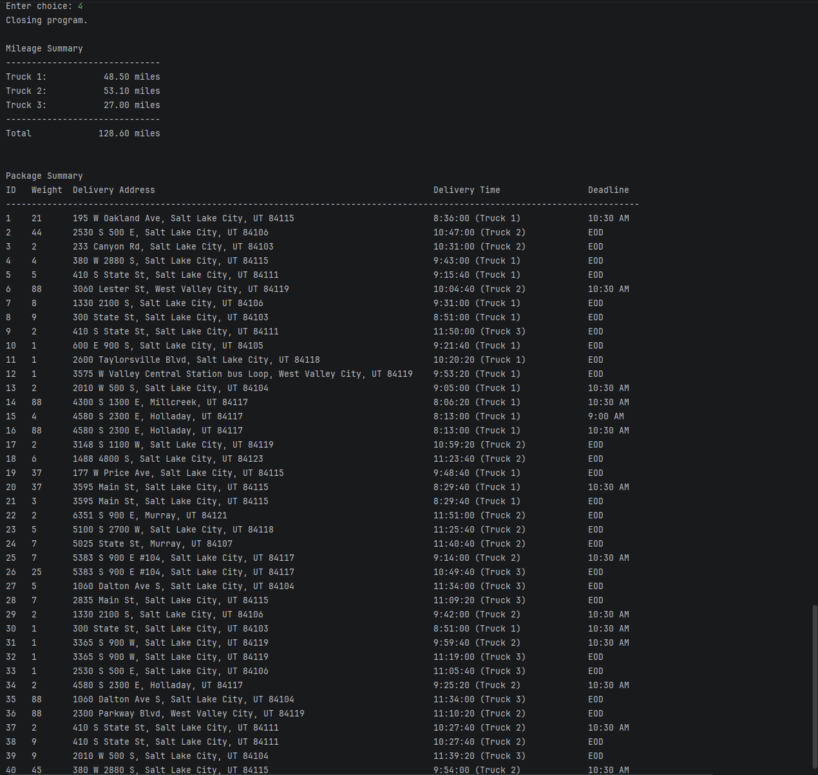

F1. Strengths of the Chosen Algorithm
The Nearest Neighbor algorithm has each truck route to the nearest undelivered address based on its current location. This algorithm is simple to implement and is somewhat efficient as it dynamically calculates routing decisions to minimize overall mileage.

F2. Verification of Algorithm
The algorithm should satisfy all requirements of the scenario as all the packages were delivered within the given timeframe, maximum truck load capacity, and maximum truck speed. Mileage is accurately tracked, both individually and the total mileage, and the delayed package was correctly handled based on its specific constraints.

F3. Other Possible Algorithms
A Brute-Force algorithm may also work for this scenario. It evaluates all possible permutations and determines the most optimal routes given the constraints, although the run-time complexity will be much less efficient. Djikstra’s algorithm could work for this project as well. Although being more computationally expensive, it ensures wholly optimal paths via full graph traversal.

F3a. Algorithm Differences
A brute-force algorithm tries each and every possible combination to find the most optimal path given the constraints of the project. “Dijkstra's algorithm finds the shortest path from one vertex to all other vertices. It does so by repeatedly selecting the nearest unvisited vertex and calculating the distance to all the unvisited neighboring vertices” (W3schools, 2025). The nearest neighbor algorithm used is a greedy approach that immediately routes to the nearest node based on the truck’s current location.

G. Different Approach
If this project were to be done again, implementing some way for the algorithm to load packages onto trucks based on address for efficient route optimization would be best. This would reduce any redundant traveling and reduce overall miles driven during the delivery day. Also implementing a priority-based delivery system to handle packages with delivery deadlines and packages that have their information needing to be corrected at a later time would be very effective for scalability.

H. Verification of Data Structure
The hash map properly stores and retrieves package information from the provided .csv file. It uses the packages’ IDs as the key and stores all other information as the values as well as providing current delivery status.

H1. Other Data Structures
- Arrays
- Graphs

H1a. Data Structure Differences
Arrays are able to lookup packages via their ID, but rather than being a key, arrays require contiguous indexing. Hash maps are as a result, more flexible in terms of storage and lookup in a realistic scenario when package IDs are not contiguous and can be stored/retrieved via hashing.
Graphs will model the delivery locations as nodes and weighted edges. With this, we can apply a search algorithm such as Djikstra’s to find short, optimal routes. This approach is more complicated and may be unnecessary for the scope of this project.

I. Sources
Lysecky, R., & Vahid, F. (2018, June). C950: Data Structures and Algorithms II. zyBooks.
Retrieved January 22, 2026, from https://learn.zybooks.com/zybook/WGUC950AY20182019/

Programming and Math Tutorials. “Python: Creating a HASHMAP Using Lists.” Www.youtube.com, 22 Jan. 2016,
Retrieved January 30, 2026 from
www.youtube.com/watch?v=9HFbhPscPU0.

W3schools. “DSA Dijkstra’s Algorithm.” Www.w3schools.com, 2025,
Retrieved February 5, 2026 from
www.w3schools.com/dsa/dsa_algo_graphs_dijkstra.php.

